PHASE 4: PROJECT PLANNING

Team ID: SWTID-2026-2976
- Project Title : Auto Ticket Classification using Flow Designer
- Platform: ServiceNow
- Phase : Phase 4- PROJECT PLANNING
Project Planning is a fundamental phase in project management that defines the project’s objectives, scope, tasks, timelines, resources, and risk management strategies before execution begins. It serves as a structured roadmap to guide the team from initialization to successful deployment while ensuring efficiency, quality, and alignment with business requirements.
In the context of the Auto Ticket Classification using Flow Designer project (SWTID-2026-2976), Project Planning involves establishing the technical requirements, execution schedule, resource mapping, and risk mitigation strategies required to automate IT helpdesk operations seamlessly within ServiceNow.

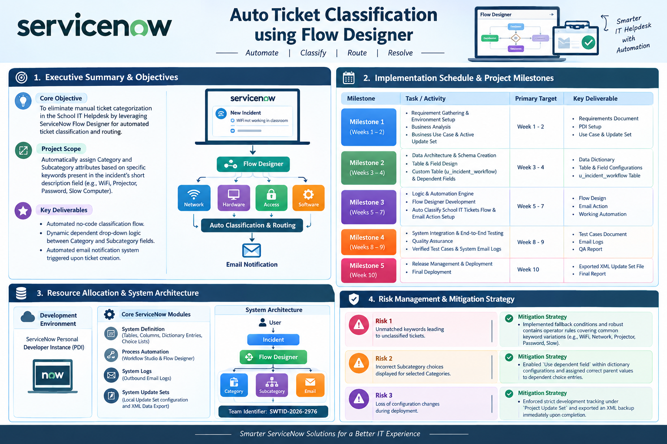

1. Executive Summary & Objectives
- Core Objective: To eliminate manual ticket categorization in the School IT Helpdesk by leveraging ServiceNow Flow Designer for automated ticket classification and routing.
- Project Scope: Automatically assign Category and Subcategory attributes based on specific keywords present in the incident's short description field (e.g., WiFi, Projector, Password, Slow Computer).
- Key Deliverables:
  - Automated no-code classification flow.
  - Dynamic dependent drop-down logic between Category and Subcategory fields.
  - Automated email notification system triggered upon ticket creation.

2. Implementation Schedule & Project Milestones
Milestone | Task / Activity | Primary Target | Key Deliverable
Milestone 1 | Requirement Gathering & Environment Setup | Business Analysis | Business Use Case & Active Update Set
Milestone 2 | Data Architecture & Schema Creation | Table & Field Design | Custom Table (u_incident_workflow) & Dependent Fields
Milestone 3 | Logic & Automation Engine | Flow Designer Development | Auto Classify School IT Tickets Flow & Email Action Setup
Milestone 4 | System Integration & End-to-End Testing | Quality Assurance | Verified Test Cases & System Email Logs
Milestone 5 | Release Management & Deployment | Final Deployment | Exported XML Update Set File & Final Report

3. Resource Allocation & System Architecture
- Development Environment: ServiceNow Personal Developer Instance (PDI).
- Core ServiceNow Modules:
  - System Definition: Tables, Columns, Dictionary Entries, and Choice Lists.
  - Process Automation: Workflow Studio & Flow Designer.
  - System Logs: Outbound Email Logs.
  - System Update Sets: Local Update Set configuration and XML Data Export.
- Team Identifier: SWTID-2026-2976

4. Risk Management & Mitigation Strategy
- Risk: Unmatched keywords leading to unclassified tickets.
  - Mitigation Strategy: Implemented fallback conditions and robust contains operator rules covering common keyword variations (e.g., WiFi, Network, Projector, Password, Slow).
- Risk: Incorrect Subcategory choices displayed for selected Categories.
  - Mitigation Strategy: Enabled Use dependent field within dictionary configurations and assigned correct parent values to dependent choice entries.
- Risk: Loss of configuration changes during deployment.
  - Mitigation Strategy: Enforced strict development tracking under Project Update Set and exported an XML backup immediately upon completion.

